**Practical – 3**

**Aim: To apply the feature scaling techniques for normalizing the data.**

* 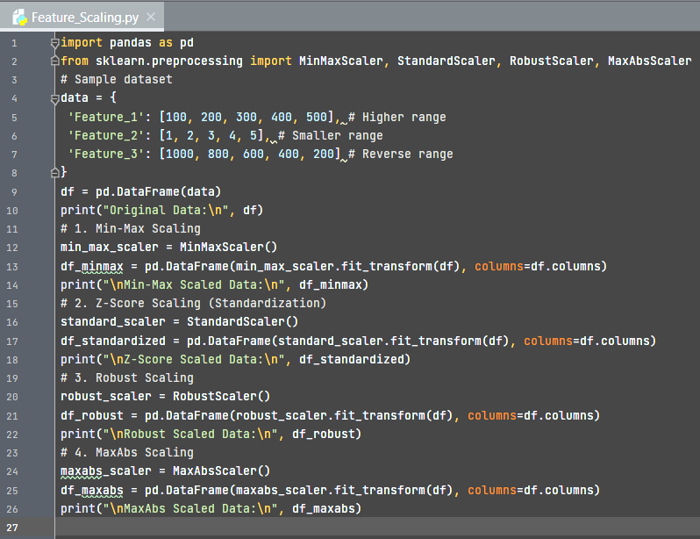**Solution:**
* 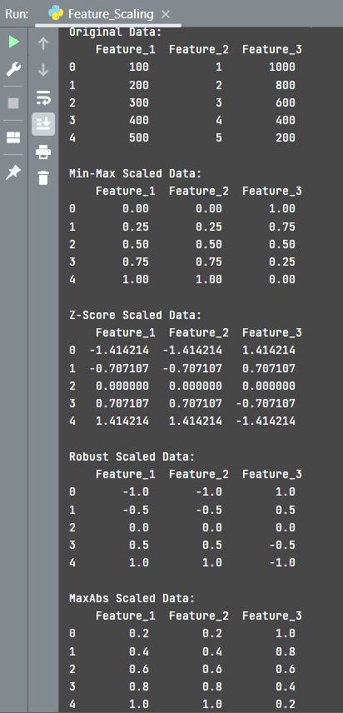**Output:**

**Practical – 4**

**Aim: To apply the feature scaling techniques for normalizing the data.**

* 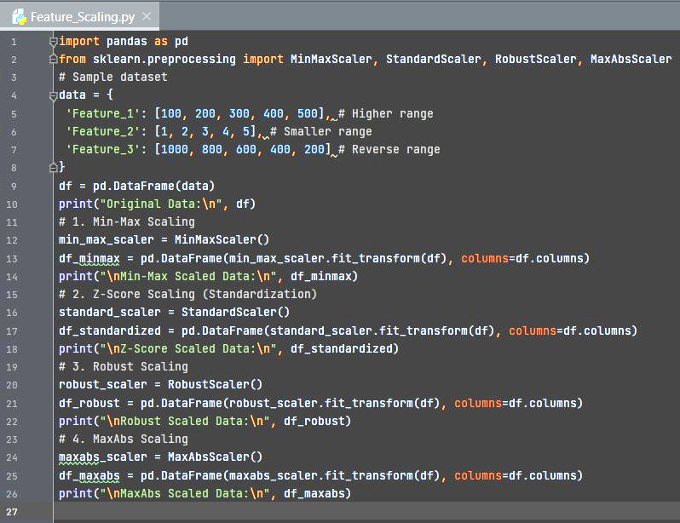**Solution:**
* **Output:**